Homework 6
- Coupling and bypass capacitor
- If the load resistance R1 is changed to 1kΩ (below left), what is the lowest frequency for good coupling? (5)

- If the series resistance R3 is changed to 10kΩ (below right), what is the lowest frequency for good bypassing? (5)
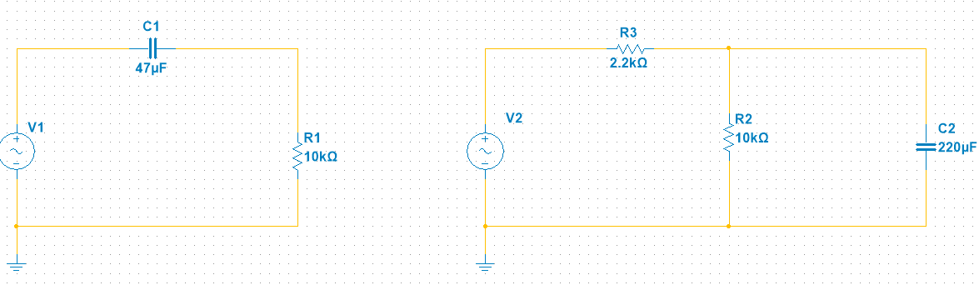

Voltage Gain (You don’t have to finish this one before lab 6. This exercise certainly helps you to design the amplifier next.)

- Simulate this (below) amplifier circuit. Apply three Voltage meters: before C1 (v_{in}), before C2 (v_{c}) and after C2 (v_{out}). Insert your simulation below with graph. (5)

The input impedance of an amplifier can load down the ac source, that is, reduce the ac voltage appearing across the emitter diode. The ac function generator has to drive the input impedance of the stage $z_{in(stage)}$. This input impedance includes the effects of the biasing resistors R₁ and R₂, in parallel with the input impedance of the base $βr_{e}^{'}$. Set $β=200$ in the simulation.

- Calculate $I_{E},r_{c}, r_{e}^{'}, A_{v,} z_{in(stage)},v_{in} and v_{out}$. Note: $v_{in}<v_{g}=1mV_{p}$ . Compare your calculation with your simulation graph. Insert your circuit and graph below. If you read from the meters on the simulation, v_{pp} is peak-to-peak voltage while 1mv_{p} is peak voltage. Be careful. (10)

- The supply voltage in this amplifier circuit increased from +10V to +20v. What’s the output voltage $v_{out}$? Compare your calculation with your simulation graph. Insert your circuit and graph below. (5)

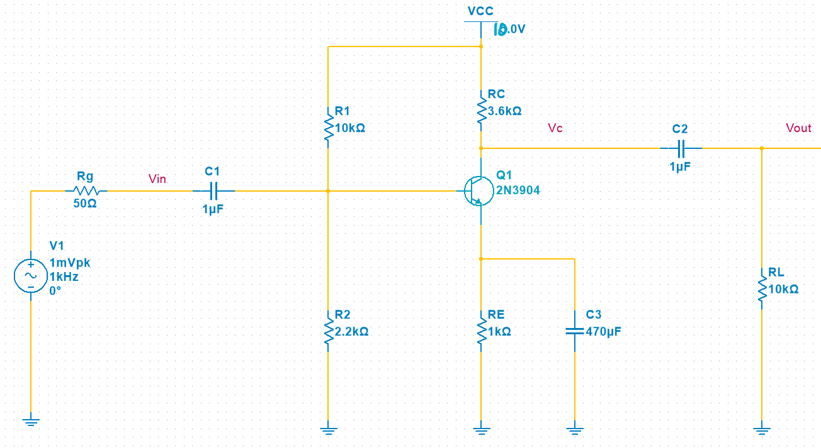
- If the emitter resistance is doubled, what is the output voltage $v_{out}$? Compare your calculation with your simulation graph. Insert your circuit and graph below. (5)
- Design a common emitter amplifier (You must finish this one before lab 6)
- Design your own CM amplifier with a 2N3904. Do not include a load resistor in this step. The output voltage is what you measure at the collector. Simulate your circuit and show the graph with v_{in} and v_{out}. Insert your circuit and graph below. (10)
Guideline:
  - The input peak voltage is $v_{in}=20mV\sim 40mV$at frequency $f=5kHz\sim 20kHz$.
  - Add a 50Ω series resistor as R_{G}.
  - The voltage divider that provides the base current should be firm if not stiff. This means that ${200Ω<R}_{2}≤0.1β_{dc}R_{E}$. Assuming beta is 200, and $\frac{R_{1}}{R_{2}}≈10$
  - $V_{CC}=15V\sim 20V$
  - Open load AC voltage gain $A_{v(open)}=50\sim 600$
  - Pick the two coupling capacitors and the one bypass capacitor. Use Multisim to aid your design by sliding through various values and observe the waveforms. You may need to change the max/min settings of the slider. Make sure your output waves are beautiful sine waves without cutoff.

- On the simulation, slide to the left of the input voltage to 2mV and compare the output waveform now with the output wave from input voltage of 20mV. Do you observe a distortion when $v_{in}=20mV$? Adjust the y scale to display the waves nicely. Insert both graphs below. (5)

- Calculate $I_{E},r_{c}, r_{e}^{'}, A_{v,} z_{in(stage)},v_{in} and v_{out}$. Since we don’t have a load resistor for now, $r_{c}=R_{C}.$The function generator output impedance is 50Ω. Taking account of the input impedance loading effect. (10)

- Apply three load resistors - 500Ω, 2kΩ and 10kΩ to your amplifier circuit. Calculate the output voltage $v_{out}$. How does the load affect the gain? Compare your calculation with your simulation graph. Insert your circuit and graph below. (10)

